Activity Overview

In this activity, you will assess the attack vectors of a USB drive. You will consider a scenario of finding a USB drive in a parking lot from both the perspective of an attacker and a target.

USBs, or flash drives, are commonly used for storing and transporting data. However, some characteristics of these small, convenient devices can also introduce security risks. Threat actors frequently use USBs to deliver malicious software, damage other hardware, or even take control of devices. USB baiting is an attack in which a threat actor strategically leaves a malware USB stick for an employee to find and install to unknowingly infect a network. It relies on curious people to plug in an unfamiliar flash drive that they find.

Be sure to complete this activity before moving on. The next course item will provide you with a completed exemplar to compare to your own work.

Scenario

Review the following scenario. Then complete the step-by-step instructions.

You are part of the security team at Rhetorical Hospital and arrive to work one morning. On the ground of the parking lot, you find a USB stick with the hospital's logo printed on it. There’s no one else around who might have dropped it, so you decide to pick it up out of curiosity.

You bring the USB drive back to your office where the team has virtualization software installed on a workstation. Virtualization software can be used for this very purpose because it’s one of the only ways to safely investigate an unfamiliar USB stick. The software works by running a simulated instance of the computer on the same workstation. This simulation isn’t connected to other files or networks, so the USB drive can’t affect other systems if it happens to be infected with malicious software.

Step-By-Step Instructions

Follow the instructions and answer the question below to complete the activity.

Step 1: Access the template

To use the template for this course item, click the link and select Use Template.

Link to template: Parking lot USB exercise

OR

If you don’t have a Google account, you can download the template directly from the following attachment.

You create a virtual environment and plug the USB drive into the workstation. The contents of the device appear to belong to Jorge Bailey, the human resource manager at Rhetorical Hospital.

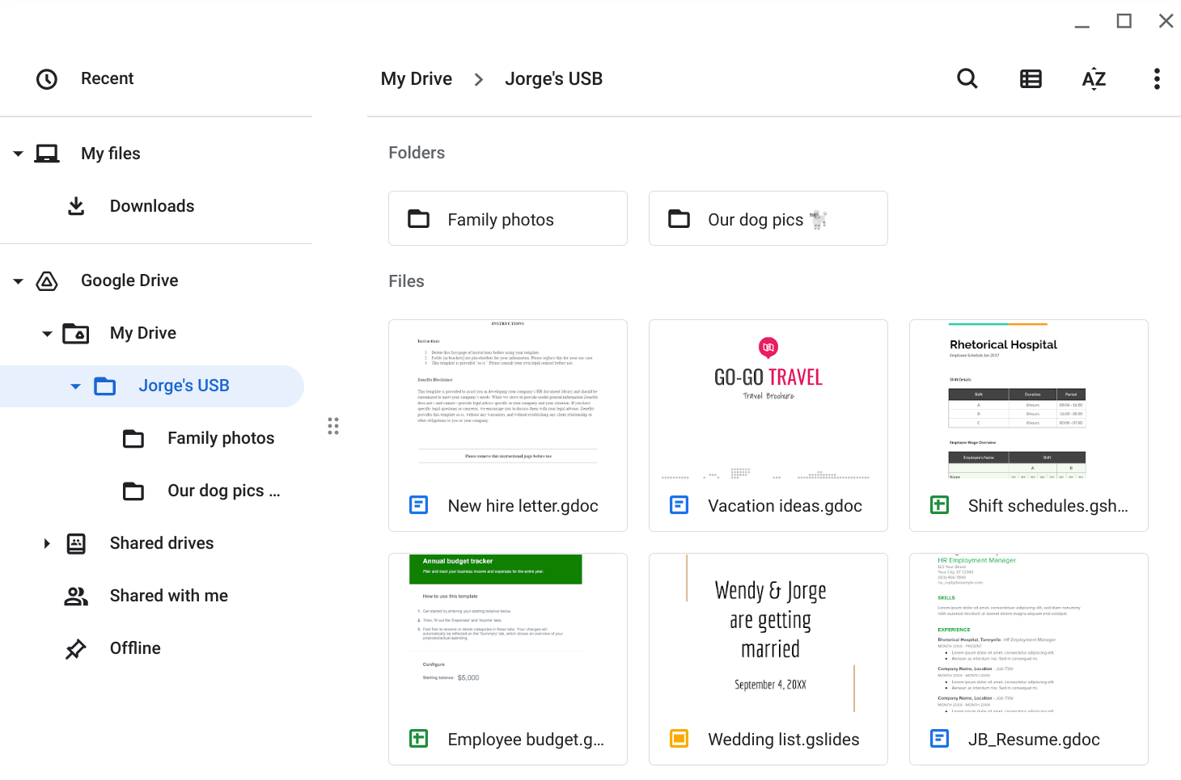

Jorge's drive contains a mix of personal and work-related files. For example, it contains folders that appear to store family and pet photos. There is also a new hire letter and an employee shift schedule.

Review the types of information that Jorge has stored on this device. Then, in the Contents row of the activity template, write 2-3 sentences (40-60 words) about the type of information that's stored on the USB drive.

Note: USB drives often contain an assortment of personally identifiable information (PII). Attackers can easily use this sensitive information to target the data owner or others around them.

The flash drive appears to contain a mixture of personal and work-related files. Consider how an attacker might use this information if they obtained it. Also, consider whether this whole event was staged.

For example, an attacker could have placed these files on the USB drive as a distraction. They might have targeted Jorge or someone he knows, hoping they would find the device and plug it into their workstation. In doing so, the attacker could establish a backdoor into the company's systems while the unsuspecting target browsed through the files.

In the Attacker mindset row of the activity template, write 2-3 sentences (40-60 words) about how this information could be used against Jorge or the hospital.

Pro tip: The Cybersecurity and Infrastructure Security Agency (CISA) provides some security tips on using caution with USB drives, including keeping personal and business drives separate.

You have not opened any of the files on the device, which is best practice.

Attackers sometimes conduct USB baiting attacks to deliver malicious code that they've crafted.

However, this USB drive was still a security risk even though it did not contain malicious code. It could have easily been found by an attacker who might have used its contents to plan a variety of attacks.

Consider some of the risks associated with USB baiting attacks:

What types of malicious software could be hidden on these devices? What could have happened if the device were infected and discovered by another employee?

What sensitive information could a threat actor find on a device like this?

How might that information be used against an individual or an organization?

In the Risk analysis row of the activity template, write 3 or 4 sentences (60-80 words) describing any technical, operational, or managerial controls that could mitigate USB baiting attacks.

What to Include in Your Response

Be sure to address the following criteria in your completed activity:

2-3 sentences about the types of information stored on the USB drive

2-3 sentences about how the information could be used against the owner and/or organization

3-4 sentences analyzing the risks of USB baiting attacks

Parking lot USB exercise

Contents | Write 2-3 sentences about the types of information found on this device.  - Are there files that can contain PII?  - Are there sensitive work files?  - Is it safe to store personal files with work files?
Attacker mindset | Write 2-3 sentences about how this information could be used against Jorge or the hospital.  - Could the information be used against other employees?  - Could the information be used against relatives?  - Could the information provide access to the business?
Risk analysis | Write 3 or 4 sentences describing technical, operational, or managerial controls that could mitigate these types of attacks:  - What types of malicious software could be hidden on these devices? What could have happened if the device were infected and discovered by another employee?  - What sensitive information could a threat actor find on a device like this?  - How might that information be used against an individual or an organization?

Contents - The USB drive appears to belong to Jorge Bailey and contains a mix of sensitive personal and professional information, including family and pet photos, personal documents, a new-hire letter, and an employee shift schedule. This combination of personally identifiable information and confidential workplace data makes the device particularly valuable to a potential attacker, as it provides both personal details that could be used for social engineering and organizational information that could be exploited to compromise hospital security. It is not safe to store personal files with work files.

Attacker mindset - An attacker who obtained this USB drive could use Jorge’s personal information, including family photos and personal documents, to craft highly convincing spear-phishing attacks targeting Jorge, his family, or new hospital employees via the new-hire letter. The employee shift schedule is particularly dangerous in the wrong hands, as it reveals exactly when specific staff members are working, allowing an attacker to time a physical or digital attack when key personnel are absent or when the hospital is most vulnerable. Most concerning is the possibility that this USB drive was intentionally planted by an attacker in the hospital parking lot as a USB baiting attack that banks on a curious employee plugging it in and unknowingly installing malware that establishes a backdoor into the hospital’s critical systems.

Risk analysis - From a technical controls perspective, the hospital should implement USB port restrictions using endpoint security software that prevents unauthorized USB devices from connecting to any workstation and automatically blocks or sandboxes unrecognized devices before they can execute malicious code.

From an operations standpoint, the hospital should establish and enforce a strict policy prohibiting employees from plugging in any USB device found in public areas, regardless of whether it appears to belong to a colleague, and should provide employees with a safe reporting procedure for turning in found devices to the security team for proper forensic analysis.

Managerially, the hospital should conduct regular security awareness training, specifically covering USB baiting attacks. This way, all employees understand the serious risk of connecting unfamiliar devices to hospital workstations. This is especially necessary given that a successful attack on a hospital network could compromise patient records, medical systems, and critical healthcare infrastructure.

Finally, the hospital should enforce a policy requiring employees to store personal and professional data on separate storage devices. This would prevent sensitive work-related information, such as shift schedules and new hire letters, from being stored alongside personal files on portable devices that could be lost or stolen.

